Software requirements specification - Group 5

Project Name: SafeMed

Team Members:
Imadeddin Ouahidi
Anji Reddy Modugula
Lohitha Vodnala

Wiki page link: https://github.com/ImadeddinOuahidi/GDP-Group5/wiki/Software-requirements-specification-%E2%80%90-Group-5

Contents
1- Project Information 3
a. Project Charter 3
b. About the Developers 3
c. Problem Statement 4
2- Design 5
a. Use cases 5
b. Functional requirements 17
c. Non-functional requirements 18
d. Data management plan 20
e. Proposed Prototypes 26
3- Meeting Minutes 29
a. Client Meeting Minutes 0 29
b. Client Meeting 1 31
c. Client meeting 2 32

Project Information

Project Charter
Brief Summary of the Problem
Lack of understanding of adverse drug reactions happens due to the lack of easy-to-use reporting tools, and duplicate submissions that waste the time of health professionals. It delays the detection of serious cases and makes patient safety monitoring inefficient.
Motivation for solving the problem
SafeMed ADR is an AI-based reporting platform with patient ability to report adverse drug events via text, voice, or photos. The platform deduplicates reports and assigns severity categorization to reduce the doctors workload, improve speed, and prioritize severe cases. This will improve the client experience by improving accuracy, and enhancing patient safety.
Required Functionality
The system must have the following functionalities:
- Different patient reporting formats (text, voice, or images).
- Automated deduplication of duplicate reports.
- AI-based severity detection (Critical, High, Medium, Low).
- Security with encryption of data for user privacy.
Requirement enginering

About the Developers
GitHub username: ImadeddinOuahidi
link to GitHub page: https://github.com/ImadeddinOuahidi
Areas of interest: Mobile and full-stack development, and Artificial intelligence integration

GitHub username: anjireddy-github
link to GitHub page: https://github.com/anjireddy-github
Areas of interest: WEB and full-stack development, and GEN-AI

GitHub username: lohithavodnala
link to GitHub page: https://github.com/lohithavodnala
Areas of interest: AI&ML, Web and mobile application development

Problem Statement
At present, the client's process of collecting and processing adverse drug reaction (ADR) reports is time consuming and inefficient. Patients can report side effects through multiple methods like paper forms, phone calls, or emails, but reports often come in different formats and sometimes miss important details. This demands that staff spend more time on verification, correction, or even disposal of reports before they can be used.
Furthermore, these different methods of reporting can compromise the patient’s privacy. For example, some patients may choose to send photos or personal documents as evidence of their reaction. However, since these files are shared through email or stored on unsecured systems, patients may lose control over sensitive information they would prefer to keep private. This lack of protection increases the risk of exposing personal health details to the wrong people, which can reduce trust in the reporting process.
Another problem is that staff often receive a lot of reports about the same event, but there is no good system to identify and combine duplicates. Staff must do this work manually, which takes a lot of time and can lead to mistakes.
There is also no clear or consistent way to decide which reports are urgent. This means serious cases may be delayed while staff go through many minor cases. In addition, reports are stored in separate systems that do not connect well. This makes it hard to track trends or analyze data.
These problems affect everyone involved. Patients find it hard to share their health problems, staff waste time on extra administrative work, and managers do not get clear and reliable data. In the end, serious safety issues may be noticed too late, which puts patients at risk and this is where SafeMed comes to solve all these problems.

Design

Use cases
Use Case 1: Submit an ADR Report
Goal: Patient submits a side effect report.
Actor: Patient
Inputs:
- Text description of side effect.
System Actions:
- Validate the input.
- Store the report securely in the database.
- Run severity analysis on the report.
Outputs:
- Confirmation message to the patient.
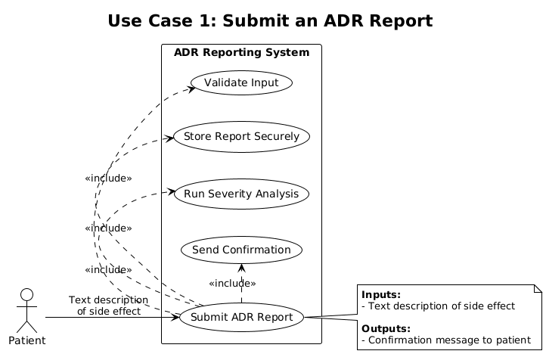

Use Case 2: Submit a Side Effect Report via Voice
Goal: Patient submits a side effect report using voice.
Actor: Patient
Inputs:
- Voice recording of the side effect.
System Actions:
- Transcribe audio to text.
- Save the transcription securely in the database.
- Run severity analysis on the transcription.
Outputs:
- Confirmation message to the patient.
- If the audio is unclear, the system prompts the patient to re-record.
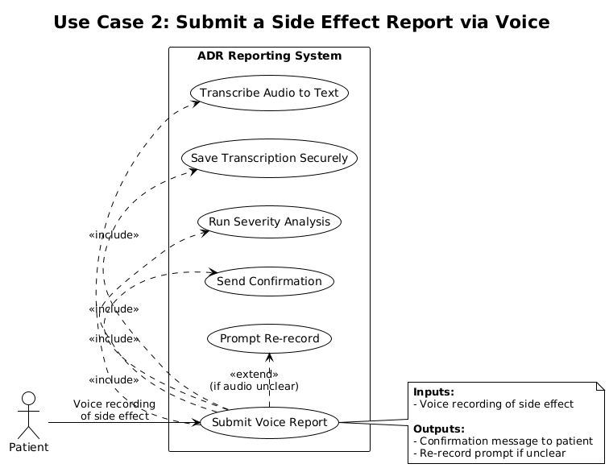

Use Case 3: Submit a Side Effect Report with Photo
Goal: Patient submits a side effect report using a photo.
Actor: Patient
Inputs:
- Photo or image showing the side effect (e.g., rash, swelling).
System Actions:
- Validate and securely upload the image.
- Store the image in the database linked to the report.
- Run AI analysis on the image and attach findings to the report.
Outputs:
- Confirmation message to the patient.
- If the image format/quality is invalid, the system prompts the patient to re-upload.
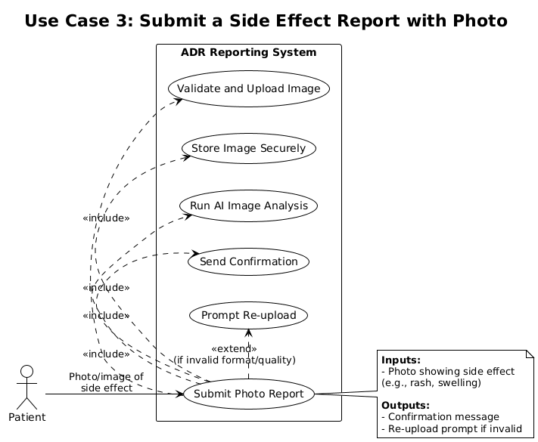

Use Case 4: Review ADR Reports
Goal: Healthcare staff reviews submitted ADR reports.
Actor: Healthcare Staff
Inputs:
- Search or filter request (e.g., by severity, date, or drug name).
System Actions:
- Authenticate staff login.
- Retrieve and display relevant ADR reports.
- Highlight any reports flagged as urgent or duplicates.
Outputs:
- Reports displayed to staff for review.
- Staff can take further action (confirm duplicates, prioritize urgent cases).
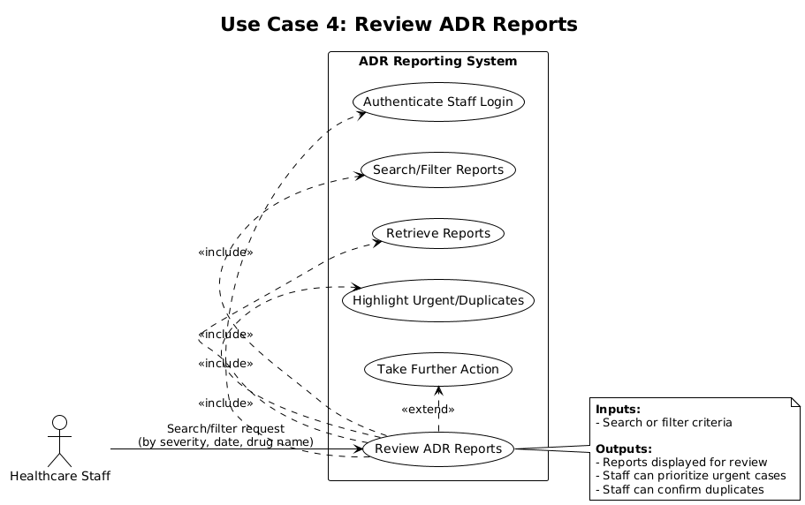

Use Case 5: Validate Submitted Report
Goal: System ensures required fields are filled.
Actor: System
Inputs:
- Patient-submitted form (text, image, or voice).
System Actions:
- Check all mandatory fields.
- Flag missing or invalid inputs.
Outputs:
- Error message if incomplete.
- Continue processing if valid.
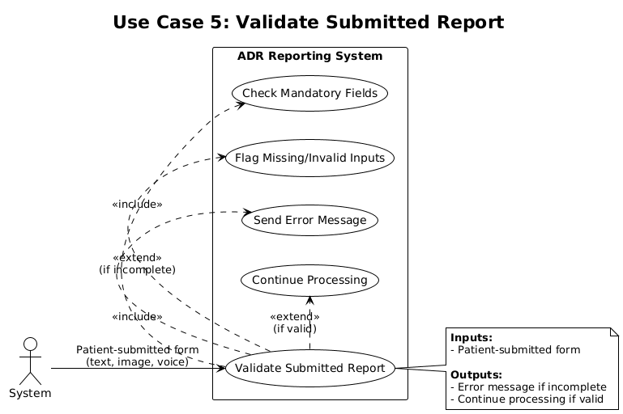

Use Case 6: Securely Store ADR Reports
Goal: System securely saves patient reports.
Actor: System
Inputs:
- Completed patient report (validated).
System Actions:
- Store report in encrypted database.
- Backup data automatically.
Outputs:
- Report stored with unique ID and timestamp.
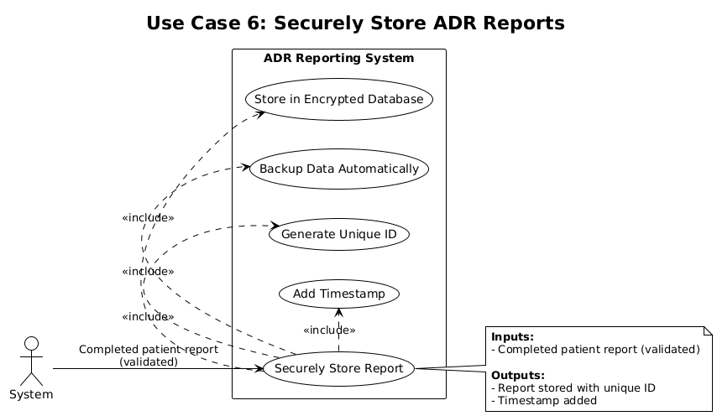

Use Case 7: Healthcare Staff Login
Goal: Staff securely access the system.
Actor: Healthcare Staff
Inputs:
- Username and password.
System Actions:
- Validate credentials against database.
- Restrict unauthorized access.
Outputs:
- Access granted to dashboard or access denied with error if invalid.
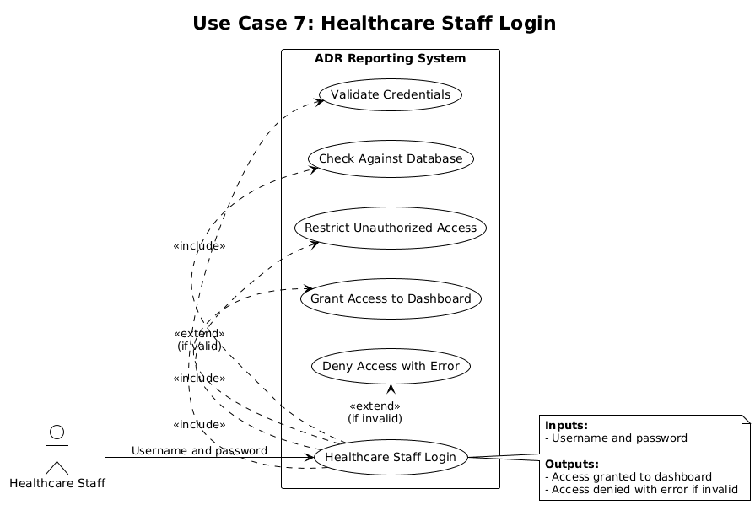

Use Case 8: Identify Duplicate Reports
Goal: System flags repeated reports.
Actor: System
Inputs:
- New patient report.
System Actions:
- Compare report with stored reports.
- Flag potential duplicates.
Outputs:
- Duplicates for staff review.
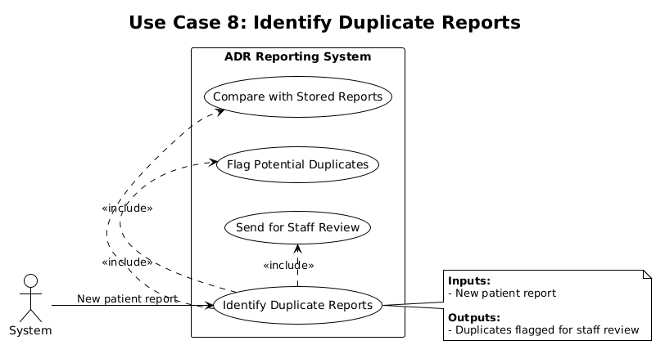

Use Case 9: Mark Report Severity
Goal: System assigns severity to each report.
Actor: System
Inputs:
- New report (validated and stored).
System Actions:
- Analyze content.
- Assign severity: Critical, High, Medium, Low.
Outputs:
- Severity stored with report.
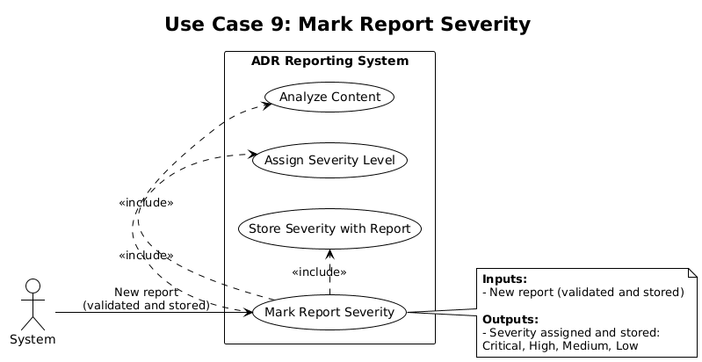

Use Case 10: Secure Upload of Reports
Goal: System handles different report formats securely.
Actor: Patient
Inputs:
- Text report, photo, or voice file.
System Actions:
- Encrypt during upload.
- Validate format and size.
Outputs:
- Confirmation of secure upload.
- Error if format or size are invalid.
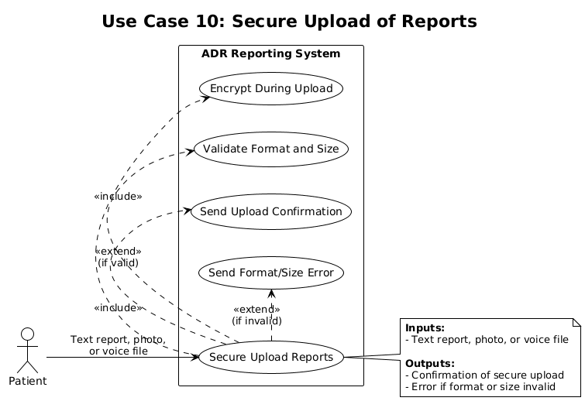

Use Case 11: Role-Based Access
Goal: Ensure different roles (Patient, Doctor) have different permissions.
Actor: System
Inputs:
- User credentials.
System Actions:
- Identify role after login.
Outputs:
- Patient: Submit and view own reports.
- Doctor: Review reports.
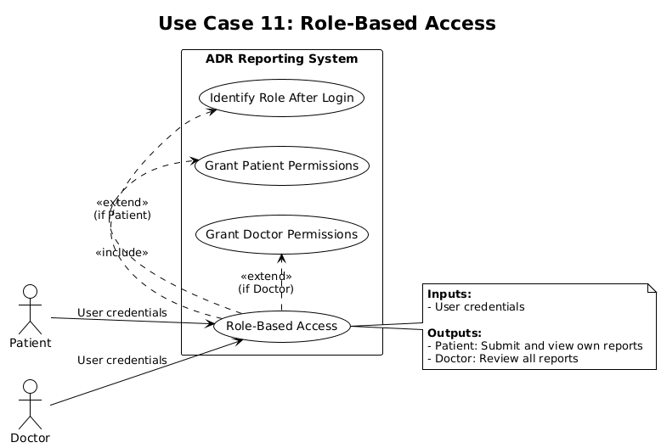

Use Case 12: Display Error Messages
Goal: Inform patients or staff when validation fails.
Actor: System
Inputs:
- Invalid or incomplete input.
System Actions:
- Detect error.
- Display meaningful error message.
Outputs:
- Error message shown.
- User prompted to fix input.
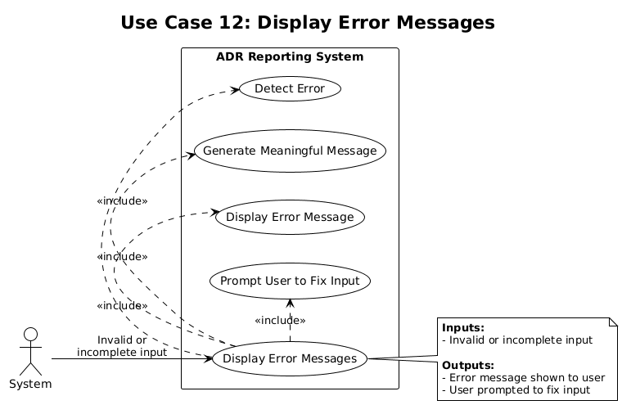

Functional requirements
The system SHALL:
- The system SHALL allow patients to submit adverse drug reaction reports through an online form.
- The system SHALL validate each submitted report to ensure required fields are filled in.
- The system SHALL store ADR reports securely in a database.
- The system SHALL allow healthcare staff to view ADR reports through a secure login.
- The system SHALL identify duplicate ADR reports for review.
- The system SHALL mark reports with the severity.
- The system SHALL provide a secure method for uploading text reports, images, or voice recordings.
- The system SHALL restrict unauthorized access to patient reports.
- The system SHALL track the date and time of each report submission.
- The system SHALL NOT store user passwords in plain text in the database.
- The system SHALL provide role-based access (patients, doctors, administrators)
- The system SHALL provide error messages when validation fails
The system SHOULD:
- The system SHOULD allow staff to filter reports by severity, date, or drug name.
- The system SHOULD generate summary statistics.
- The system SHOULD notify staff when a new urgent report is submitted.
- The system SHOULD allow patients to check the status of their report submission.
- The system SHOULD provide a printable summary of individual reports.
The system MAY:
- The system MAY allow exporting reports in standard formats.
- The system MAY allow visualization of trends with charts and graphs.
- The system MAY provide multilingual support for patients.

Non-functional requirements
1. Performance
- Report submission and validation should complete within 5 to 10 seconds under normal network conditions.
- The dashboard should load within 3 seconds on a standard broadband connection.
- The system should handle up to 500 concurrent users without degradation beyond 20% of the stated response times.
2. Security
- All patient data must be encrypted in transit (TLS 1.3) and at rest (AES-256).
- File uploads must be virus-scanned and validated before storage.
- Role-based access control (RBAC) must ensure:
  - Patients cannot view or alter other patients’ data.
  - Doctors can only access patient records for individuals under their care.
- Implement multi-factor authentication (MFA) for all staff logins.
- Maintain audit logs for access, modifications, and deletions of sensitive data.
3. Reliability
- Data must not be lost in the event of a crash; reports are to be stored with automatic backups every 24 hours.
- Backups should be replicated to a secondary data center for disaster recovery.
- Upon a crash or outage, the system should recover within 15 minutes of restart.
- System uptime should be maintained at ≥ 99.5 % over any 30-day period.
4. Usability
- The user interface must be simple, intuitive, and consistent across all pages.
- Error messages should be:
  - Clear and actionable, e.g., “File format not supported: please upload image formats”
  - Localized for different user roles (e.g., patient vs. staff).
- The system must be accessible on desktop and mobile devices with responsive design.
- Follow WCAG 2.1 Level AA accessibility standards.
5. Privacy
- Collect only necessary personal data required for functionality (data minimization).
- Define a data-retention policy:
  - Patient medical records retained for 7 years after last activity.
  - Logs and uploads automatically purged after retention period.
- Uploaded files must be accessible only to authorized staff.
- Ensure compliance with GDPR/HIPAA principles for patient consent, right to erasure, and data transparency.
6. Availability
- The system should maintain a 99.5 % uptime guarantee measured monthly.
- Implement redundant servers and automatic failover to maintain service continuity.
- Schedule maintenance only during off-peak hours (e.g., 2 AM – 4 AM UTC).
- Provide real-time status monitoring for critical services.
7. Scalability
- The system should support horizontal scaling (adding servers) and vertical scaling (upgrading resources) without downtime.
- Bandwidth capacity must sustain data transfer up to 200 MB per transaction without packet loss.
- APIs and databases must handle increasing transaction volumes without schema changes.

Data management plan
1. Summary of Data to Store
Our system uses MongoDB to manage data in flexible JSON-style documents. The main entities are:
Users Collection (users)
- Stores patients and doctors.
- _id
- firstName, lastName, email, phone, dateOfBirth, gender, address
- role (patient, doctor, admin)
- password (hashed, never plain text)
- doctorInfo (license, specialization, consultation fee, etc.)
- patientInfo (blood group, allergies, chronic conditions, emergency contact, insurance info)
- isActive, isEmailVerified, timestamps
Medicines Collection (medicines)
- Stores detailed medicine information.
- _id
- name, genericName, brandName
- manufacturer (name, country, licenseNumber)
- category, therapeuticClass, drugClass
- dosageForm, strength, route
- prescriptionRequired, controlledSubstance
- knownSideEffects (effect, severity, frequency)
- interactions (drug-drug, food, disease)
- dosing (adult, pediatric, elderly)
- storage, shelfLife, approvalInfo
- pricing, availability
- warnings, precautions
- audit fields (createdBy, updatedBy, timestamps)

Report Side Effects Collection (reportSideEffects)
- Stores adverse drug reaction (ADR) reports.
- _id
- reportedBy (User ID), reporterRole
- medicine (Medicine ID) + medicineDetails
- patient (User ID) + patientInfo
- sideEffects (effect, severity, onset, duration, treatment)
- medicationUsage (indication, dosage, start/end dates, adherence)
- reportDetails (incidentDate, seriousness, outcome, reportDate)
- causalityAssessment (algorithm, score, assessedBy)
- followUp (corrections, updates, notes)
- status (Draft, Submitted, Under Review, Reviewed, Closed)
- priority (Low, Medium, High, Critical)
- regulatoryInfo (authority reports, expedited deadlines)
- dataQuality (completeness, qualityScore)
- audit trail (lastModifiedBy, version, timestamps)
Symptom Progression Collection (symptomProgressions)
- Tracks long-term symptom data for patients.
- _id
- originalReport (ReportSideEffect ID)
- patient (User ID), medicine (Medicine ID)
- symptom (name, bodySystem, description)
- timeline (startDate, endDate, totalDuration, ongoing)
- progressionEntries (entryDate, severity, frequency, pattern, impact, interventions, notes)
- analytics (trendDirection, averageSeverity, improvementRate)
- alerts (critical warnings for worsening symptoms)
- status (Active, Resolved, Chronic, Closed)
- timestamps

2. Sample Documents
Since MongoDB is non-relational, here are example JSON documents from each collection:
User (Patient)
{
"_id": "ObjectId('652dbe1234ab56cdef901234')",
"firstName": "Sarah",
"lastName": "Williams",
"email": "sarah.williams@example.com",
"role": "patient",
"patientInfo": {
"bloodGroup": "O+",
"allergies": ["Penicillin"],
"chronicConditions": ["Asthma"]
},
"isActive": true,
"createdAt": "2025-10-09T12:00:00Z"
}
User (Doctor)
{
"_id": "ObjectId('652dbe1234ab56cdef901235')",
"firstName": "Dr. John",
"lastName": "Smith",
"email": "john.smith@hospital.org",
"role": "doctor",
"doctorInfo": {
"licenseNumber": "MD123456",
"specialization": "Cardiology",
"yearsOfExperience": 15,
"consultationFee": 200
},
"isActive": true,
"createdAt": "2025-10-09T12:00:00Z"
}
Medicine
{
"_id": "ObjectId('652dbe1234ab56cdef901236')",
"name": "Lisinopril 10mg",
"genericName": "Lisinopril",
"brandName": "Zestril",
"manufacturer": {
"name": "Pharma Inc.",
"country": "USA"
},
"category": "Antihypertensive",
"dosageForm": "Tablet",
"prescriptionRequired": true
}
Report Side Effect
{
"_id": "ObjectId('652dbe1234ab56cdef901237')",
"reportedBy": "ObjectId('652dbe1234ab56cdef901234')",
"reporterRole": "patient",
"medicine": "ObjectId('652dbe1234ab56cdef901236')",
"patient": "ObjectId('652dbe1234ab56cdef901234')",
"sideEffects": [
{
"effect": "Severe stomach pain",
"severity": "Severe",
"onset": "Within hours",
"duration": { "value": 2, "unit": "days" }
}
],
"reportDetails": {
"incidentDate": "2025-10-07",
"reportDate": "2025-10-09",
"seriousness": "Serious",
"outcome": "Hospitalization"
},
"status": "Submitted",
"priority": "High",
"createdAt": "2025-10-09T12:00:00Z"
}
Symptom Progression
{
"_id": "ObjectId('652dbe1234ab56cdef901238')",
"originalReport": "ObjectId('652dbe1234ab56cdef901237')",
"patient": "ObjectId('652dbe1234ab56cdef901234')",
"medicine": "ObjectId('652dbe1234ab56cdef901236')",
"symptom": {
"name": "Stomach Pain",
"bodySystem": "Gastrointestinal"
},
"timeline": { "startDate": "2025-10-07", "isOngoing": true },
"progressionEntries": [
{
"entryDate": "2025-10-08",
"daysSinceOnset": 1,
"severity": { "level": "Severe", "numericScore": 8 },
"frequency": "Constant",
"pattern": "Worsening"
}
],
"analytics": { "trendDirection": "Worsening", "averageSeverity": 8 },
"status": "Active",
"createdAt": "2025-10-09T12:00:00Z"
}

3. Initial Security Plan
Authentication & Authorization
- Passwords stored with bcrypt hashing (never plain text).
- Role-based access control (patient, doctor).
Access Restriction
- Patients can only view their own reports.
- Doctors can view reports.
Encryption
- HTTPS/TLS for all communication.
- MongoDB encryption at rest for sensitive collections.
4. Mapping Functional Requirements to Data Storage
Functional Requirement | Relevant Model(s) | Fields / Mechanism
Submit ADR report | reportSideEffects | reportedBy, medicine, sideEffects, reportDetails
Validate reports | reportSideEffects schema | Required fields: reportedBy, medicine, sideEffects.effect
Securely store reports | reportSideEffects, symptomProgressions | Encrypted collections
Staff secure login | users | Role-based (doctor)
Identify duplicates | reportSideEffects | Combination of patient + medicine + effect
Mark severity | reportSideEffects.sideEffects.severity | Auto-priority assignment
Secure uploads | reportSideEffects | File upload fields for text report or voice audio file or an image
Restrict unauthorized access | users.role | Access middleware
Track submission time | reportSideEffects.reportDetails.reportDate | Auto timestamps
No plain text passwords | users.password | bcrypt hashing
Role-based access | users.role | Patient/Doctor/Administrator separation
Validation errors | API + schema validation | Custom error messages

Proposed Prototypes
Prototype 1: Text-Based ADR Report Submission
Goal: Allow patients to submit detailed adverse drug reaction (ADR) reports securely.
Features:
- Validates required fields before submission.
- Stores reports in an encrypted database.
- Runs automated severity analysis on the submitted text.
- Displays confirmation or error messages.
- Integrated with duplicate detection and role-based access modules.

Prototype 2: Voice-Based ADR Report Submission
Goal: Enable patients to submit reports using voice input for improved accessibility.
Features:
- Voice recording feature for patients.
- Automatic speech-to-text transcription using AI.
- Severity analysis based on transcription results.
- Secure audio upload and confirmation feedback.

Prototype 3: Photo-Based ADR Report Submission
Goal: Allow patients to attach images of physical side effects.
Features:
- Secure image upload (JPG/PNG).
- Format and size validation.
- AI-powered image analysis to detect visual severity indicators.
- Linking images to corresponding patient reports.

Prototype 4: Duplicate Report Detection
Goal: Identify and flag potential duplicate ADR submissions.
Features:
- Compare new submissions (text, photo, or voice) against existing reports.
- Automatically flag duplicates for doctor/staff review.

Prototype 5: Doctor Review Dashboard
Goal: Provide healthcare staff with a secure dashboard for reviewing ADR reports.
Features:
- Role-based access control for staff users.
- Login and authentication system for authorized access.
- Filter/search reports by severity, date, or drug name.
- Highlight urgent or duplicate cases.
- Ability to mark reports as “Reviewed” or “Requires Follow-up.”
- Clean, responsive interface for usability.

Prototype 6: Secure Data Management System
Goal: Ensure all ADR submissions are securely stored and backed up.
Features:
- Encrypted database storage for text, audio, and images.
- Automatic backups and recovery system.
- Data access rules based on user roles (Patient/Doctor).

Prototype 7: Error Handling and Validation
Goal: Provide meaningful feedback when validation fails.
Features:
- Display clear error messages for missing or invalid inputs.
- Different messages for text, voice, and image reports.
- Guide users to correct and resubmit.

Prototype 8: Role-Based Access and Authentication
Goal: Differentiate access and permissions between Patients and Healthcare Staff.
Features:
- Secure login for both user types.
- Patients: submit and view personal reports only.
- Doctors: view, filter, and manage multiple reports.
- Restrict unauthorized access.

Meeting Minutes

Client Meeting Minutes 0
Date:
August 29, 2025
Duration:
15 minutes

Attendees:
Team Members: Imadeddin Ouahidi, Anji Reddy, Lohitha Vodnala
Client: Dr. Mark Chai
Meeting Agenda:
Discussing the project specifications and requirements
Questions And Answers:
Question (Dr. Chai): What are the input criteria?
Answer (Imadeddin): Inputs will include patient reports in the form of text, voice, or photos. Reports can be submitted in multiple languages (English, Chinese initially).

Question (Dr. Chai): What are the output criteria?
Answer (Lohitha): The outputs will be a severity score of the reported side effect and a categorized summary visible to the doctor. The system will also identify and merge duplicate reports.

Question (Dr. Chai): What are the roles of the team?
Answer (Imadeddin):
Imadeddin: Project Lead Frontend developer.
Anji: AI development and integration.
Lohitha: Backend and database design.

Question (Dr. Chai): What are the functional and non-functional requirements?
Answer (Team):
Functional: Severity detection, doctor notification. Non-functional: Data privacy, user-friendly interface.

Question (Dr. Chai): Which AI model will be used?
Answer (Anji): We still have to make a deep search to find a good and preferably pre trained model that we will use, but generally we will use some classification model to detect severity.
Action items:
In the next meeting we will show the client how we will organize the cross-platform app interactions and what are the functions includes. Additionally, we will share findings on the AI models that we may use.
Next meeting:
September 5, 2025

Client Meeting 1
Date:
September 03, 2025
Duration:
15 minutes
Attendance
Team Members: Imadeddin Ouahidi, Anji Reddy, Lohitha Vodnala
Client: Dr. Mark Chai
Meeting Agenda
- Clarify use of wiki pages and comments for documentation.
- Discuss responsibility for system engineering tasks and assignments.
- Review documentation quality and feedback.
- Confirm citation and reference requirements.
- Outline expectations for project requirements and possible demo.
Questions Asked & Answers
- Q (Anji): Can we use wiki pages for documentation, or just comments?
A (Dr. Chai): Yes, you may use wiki pages. Comments don’t count as wiki pages, so make sure project-related documentation is placed in the wiki.
- Q (Lohitha): Who is responsible if there’s a mistake in the system engineering section?
A (Dr. Chai): The group shares responsibility, but each member must take ownership of their assigned part. The project manager oversees grouping and organization.
- Q (Dr. Chai): Who designed the test documentation?
A (Imadeddin): I created the layout and some answers; others edited answers.
- Q (Dr. Chai): Why is there only two citation in the text?
A (Imadeddin): I added the first one, but others were divided among members.
A (Dr. Chai): As team leads, everyone is responsible for ensuring full and consistent references.
- Q (Dr. Chai): Do you understand the importance of requirements documentation?
A (Group): Yes, we will expand functional and non-functional requirements and detail technology choices.
Action Items
- Add more citations and ensure they are consistent across all documentation.
- Expand functional and non-functional requirements with more detail.
- Document technology choices clearly.
- Consider creating a demo or prototype to make requirements easier to understand (if time allows).
- Continue to use the wiki for documentation instead of only relying on comments.
Next Meeting
September 12, 2025

Client meeting 2
Date:
September 12, 2025
Duration:
15 minutes
Attendance
Team Members: Imadeddin Ouahidi, Anji Reddy, Lohitha Vodnala
Client: Dr. Mark Chai
Meeting Agenda
- Discussion of three main problems identified in reports.
- Clarification of issues related to reporting, duplication, and privacy.
- Next steps for updating documentation and functional requirements.
Discussion Summary
Problem 1: Different Formats of Reports
- Issue: Reports are submitted in several inconsistent formats.
- Action: Need to standardize reporting structure for easier review.
Problem 2: Duplicate Reports
- Issue: Multiple reports contain the same events, leading to redundancy.
- Action: Implement a method to merge or filter duplicates.
Action Items
- Update the report with more details on privacy concerns.
- Review and correct inconsistencies in report formatting.
- Propose a solution for handling duplicate reports.
Next Meeting
September 19, 2025

